**Install Jenkins**

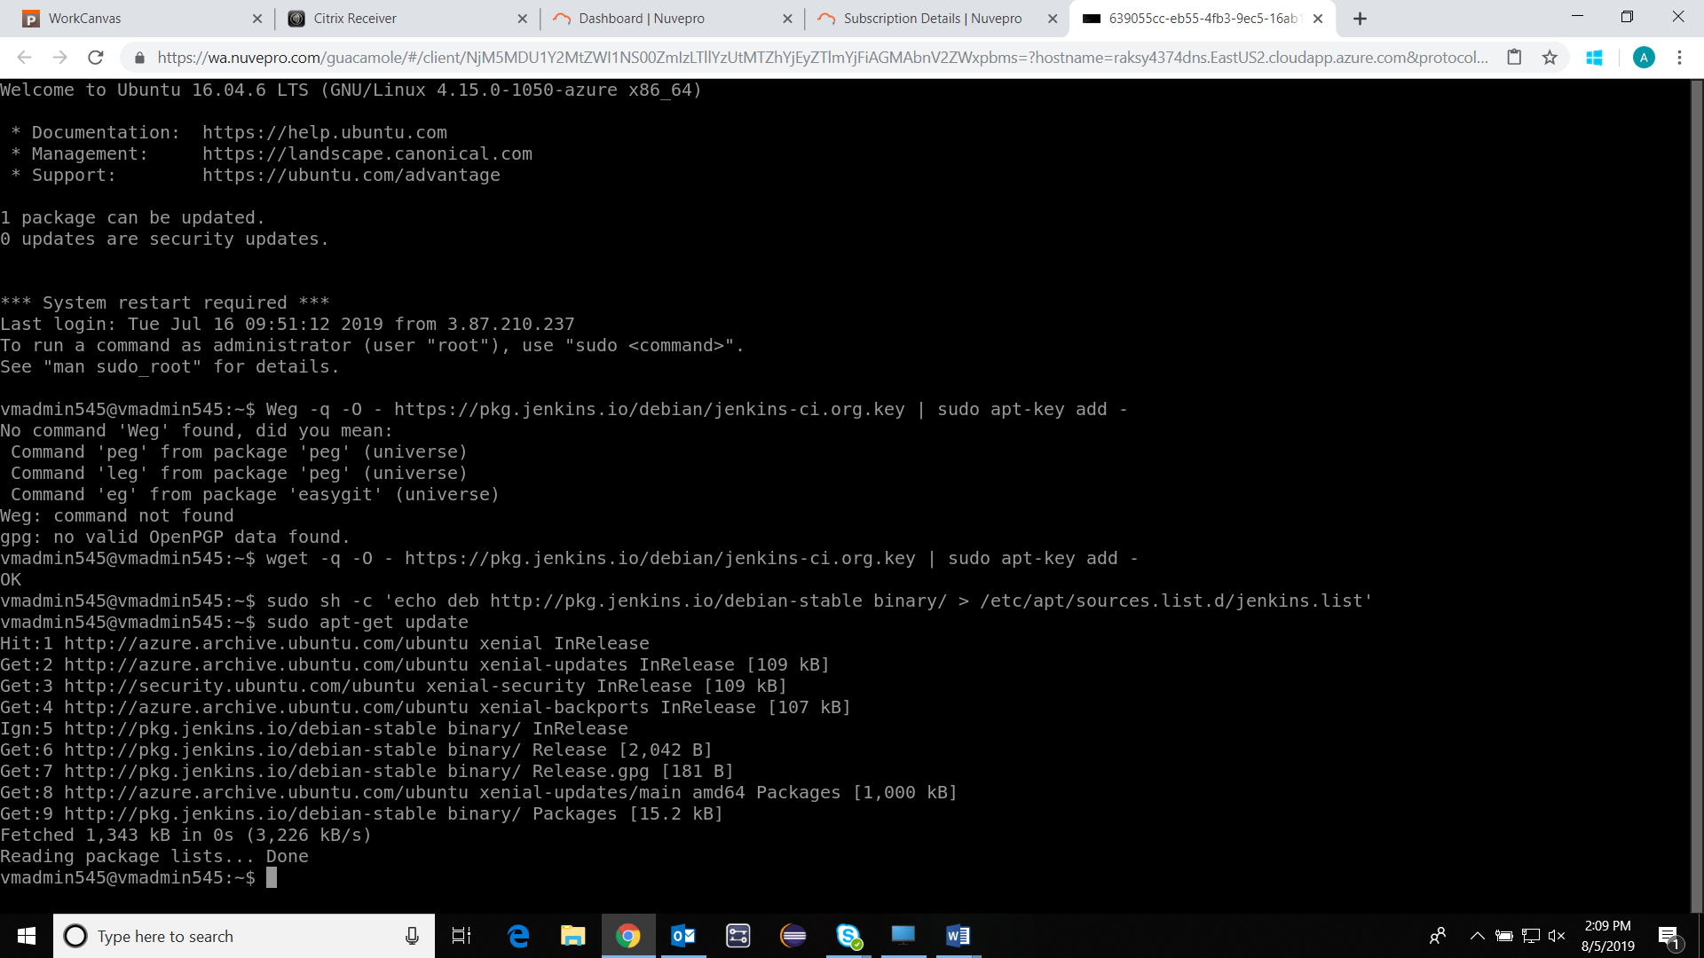

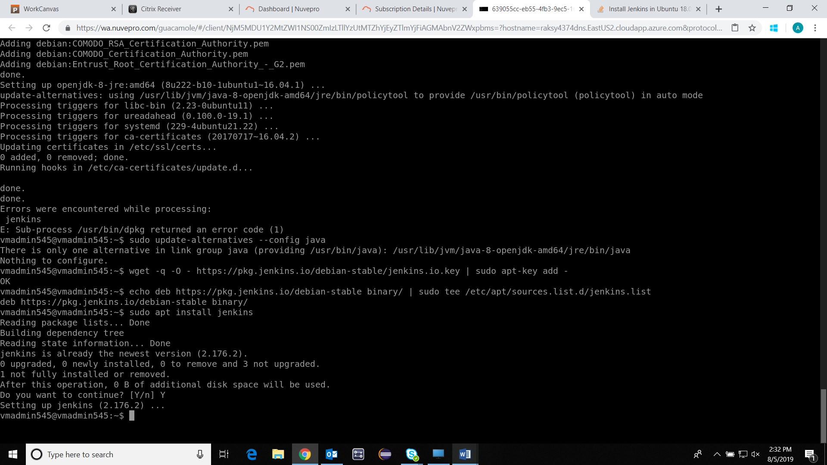

**Start Jenkins**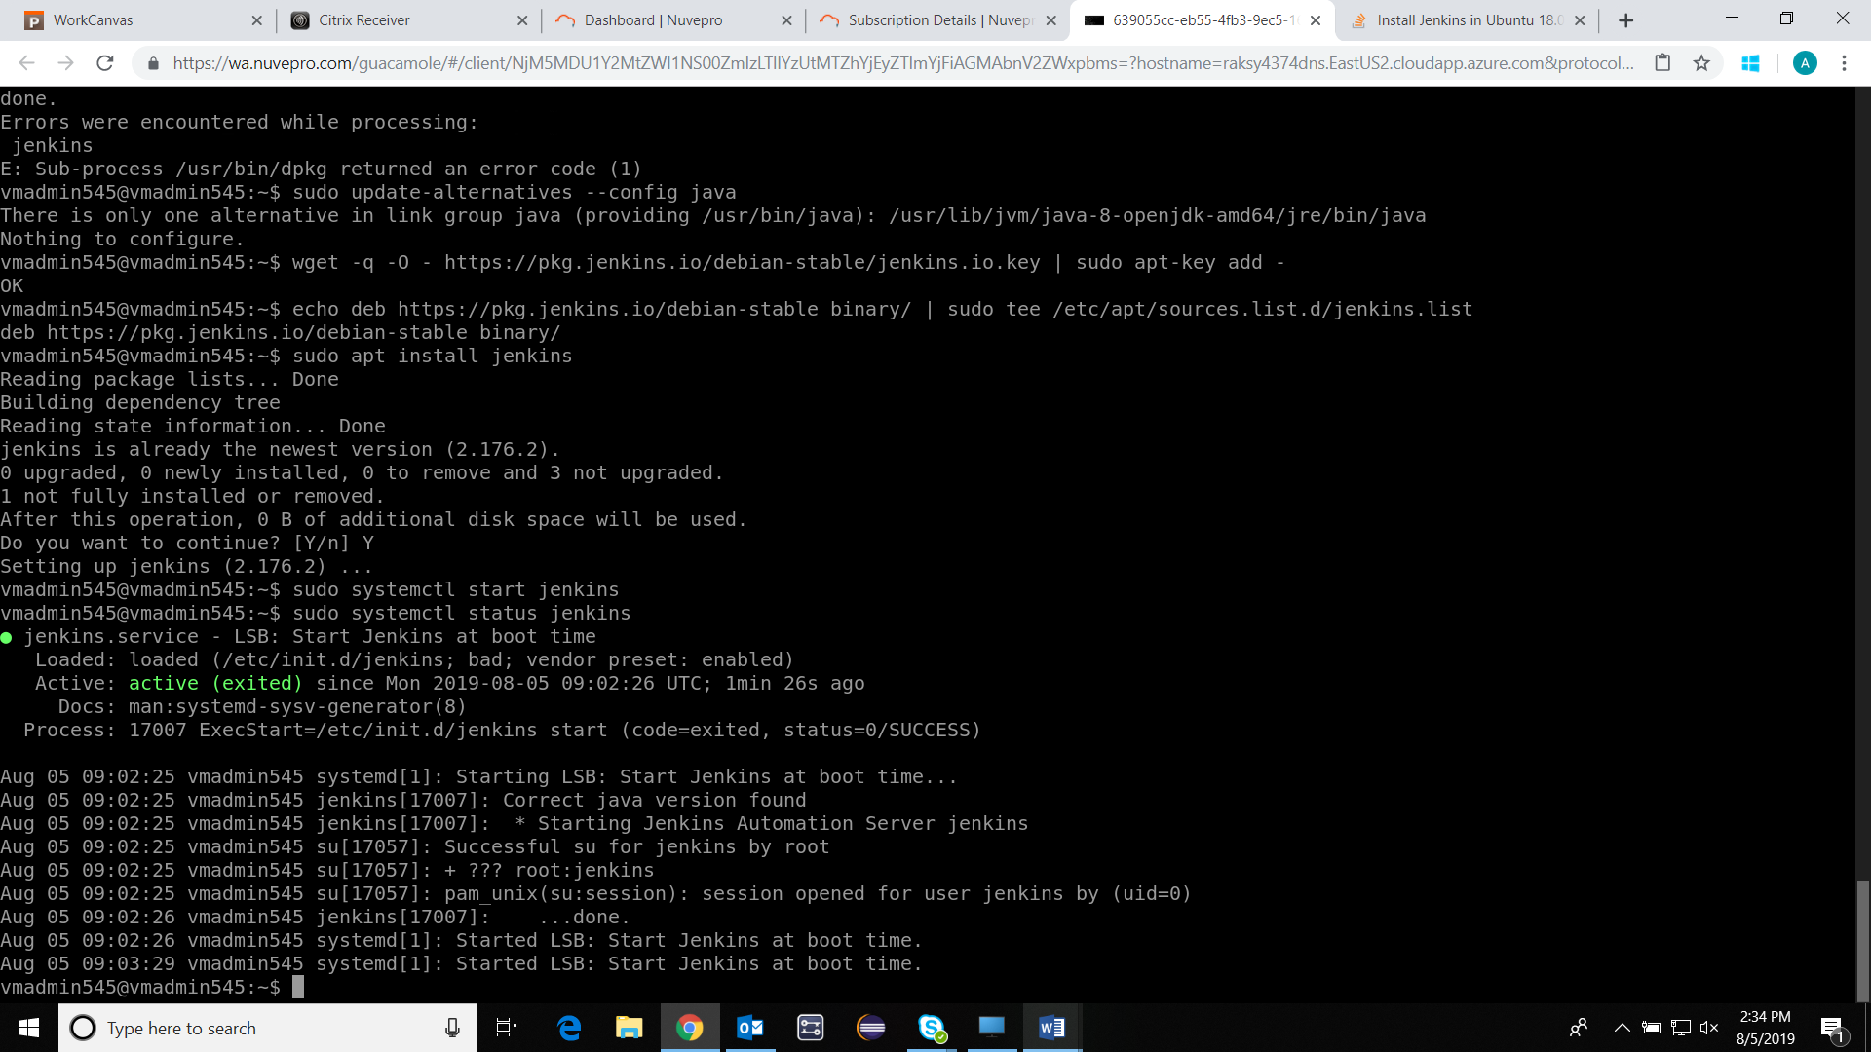

**Opening the Firewall** 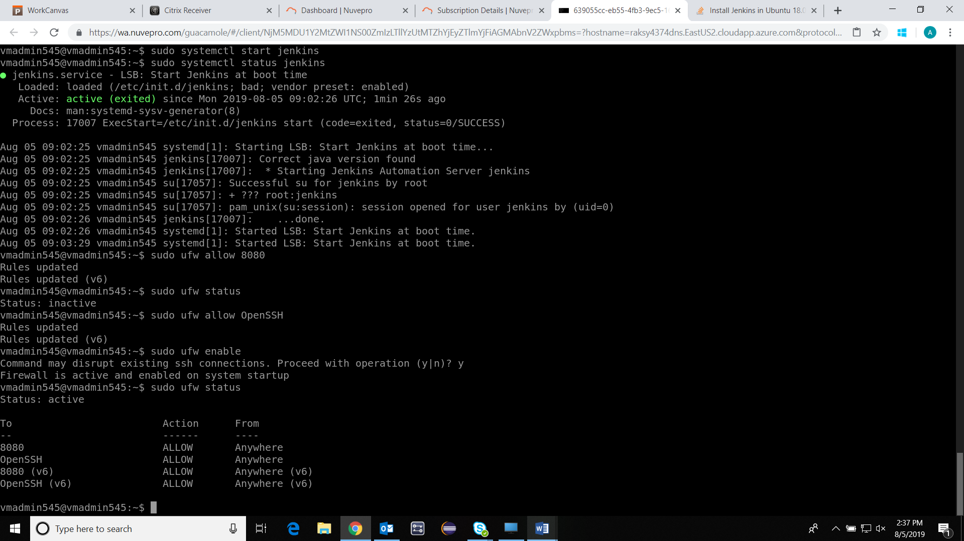

**Setting up the Jenkins: raksy4374dns.EastUS2.cloudapp.azure.com**

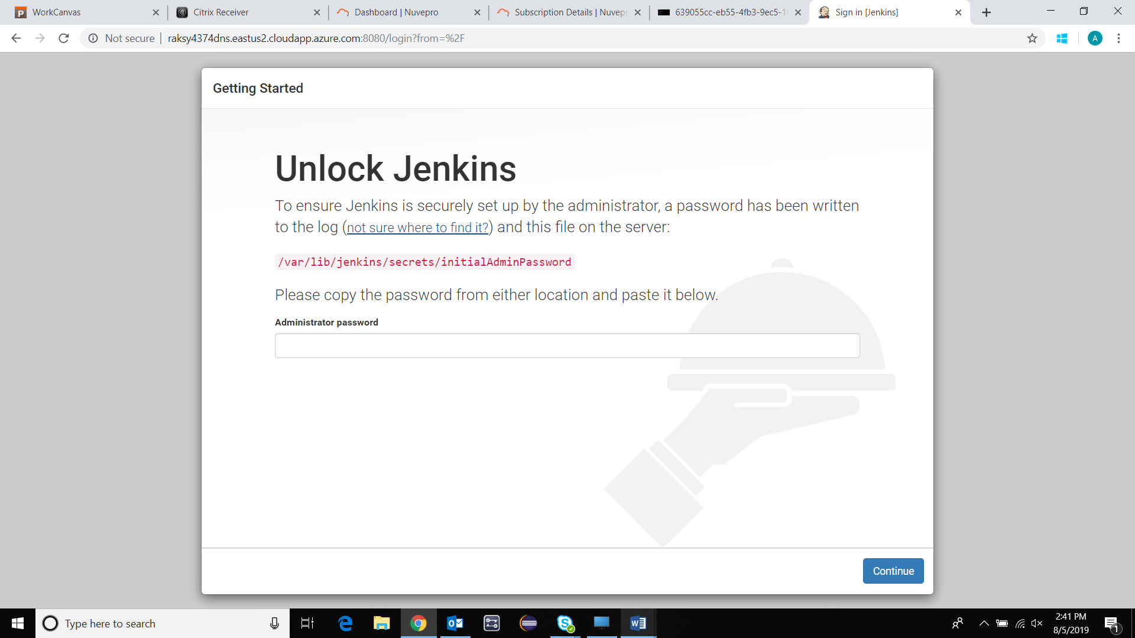

**sudo cat /var/lib/jenkins/secrets/initialAdminPassword** 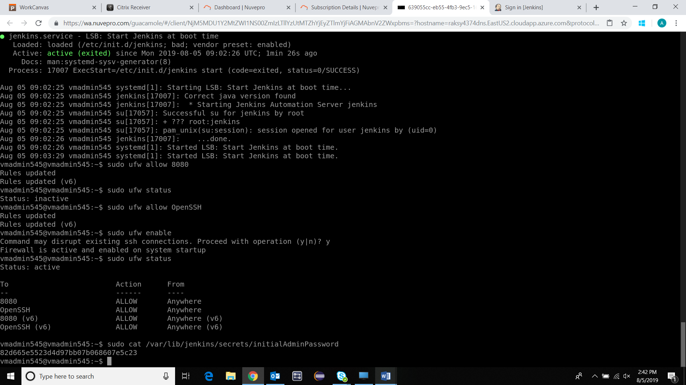

**Password: 82d665e5523d4d97bb07b068607e5c23**

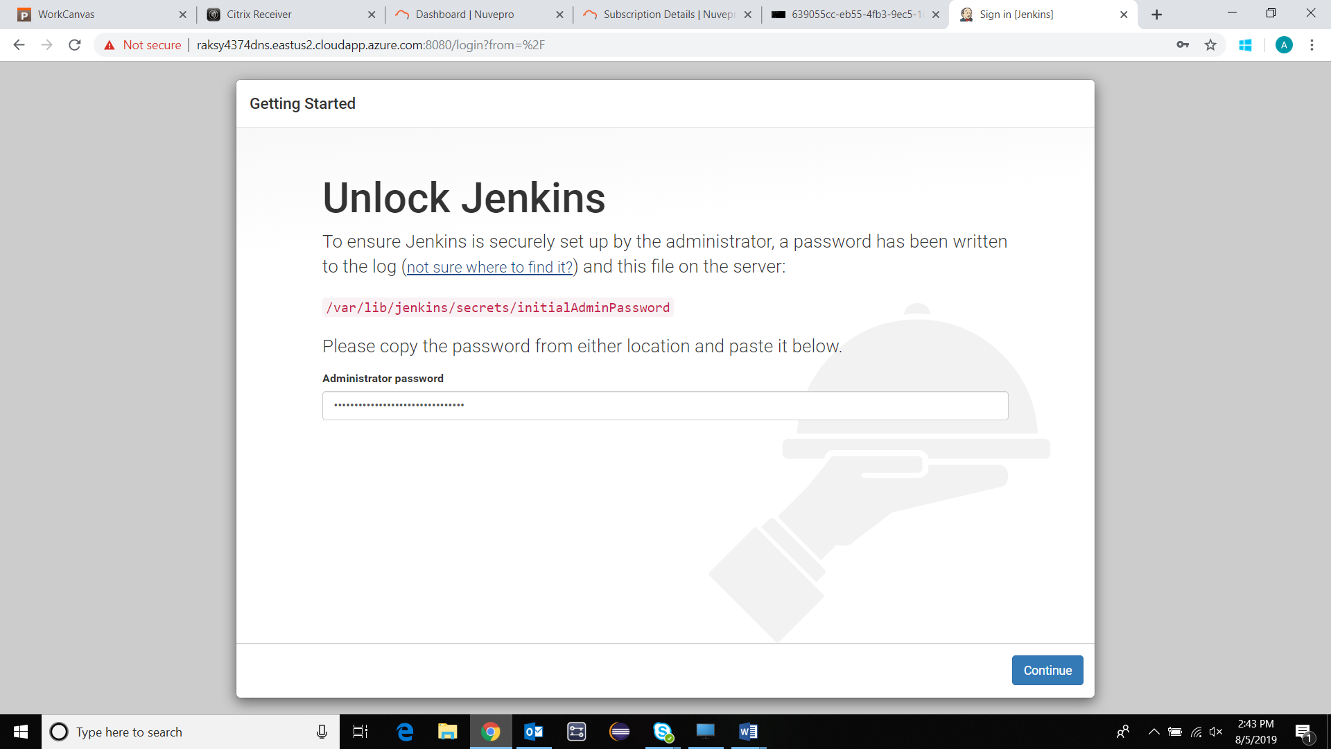

**CONTINUE** 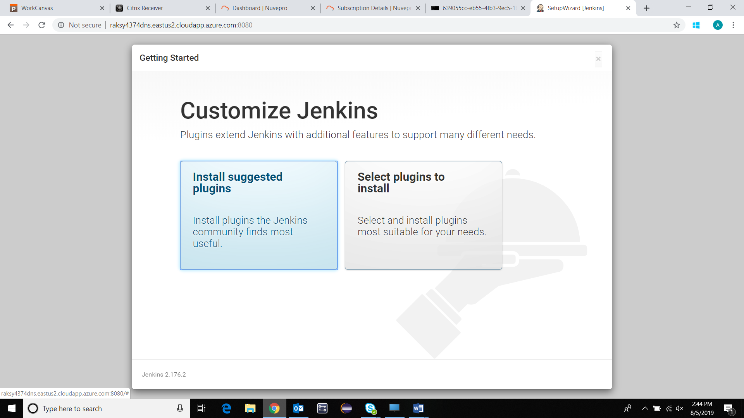

**Click on Install suggested plugins** 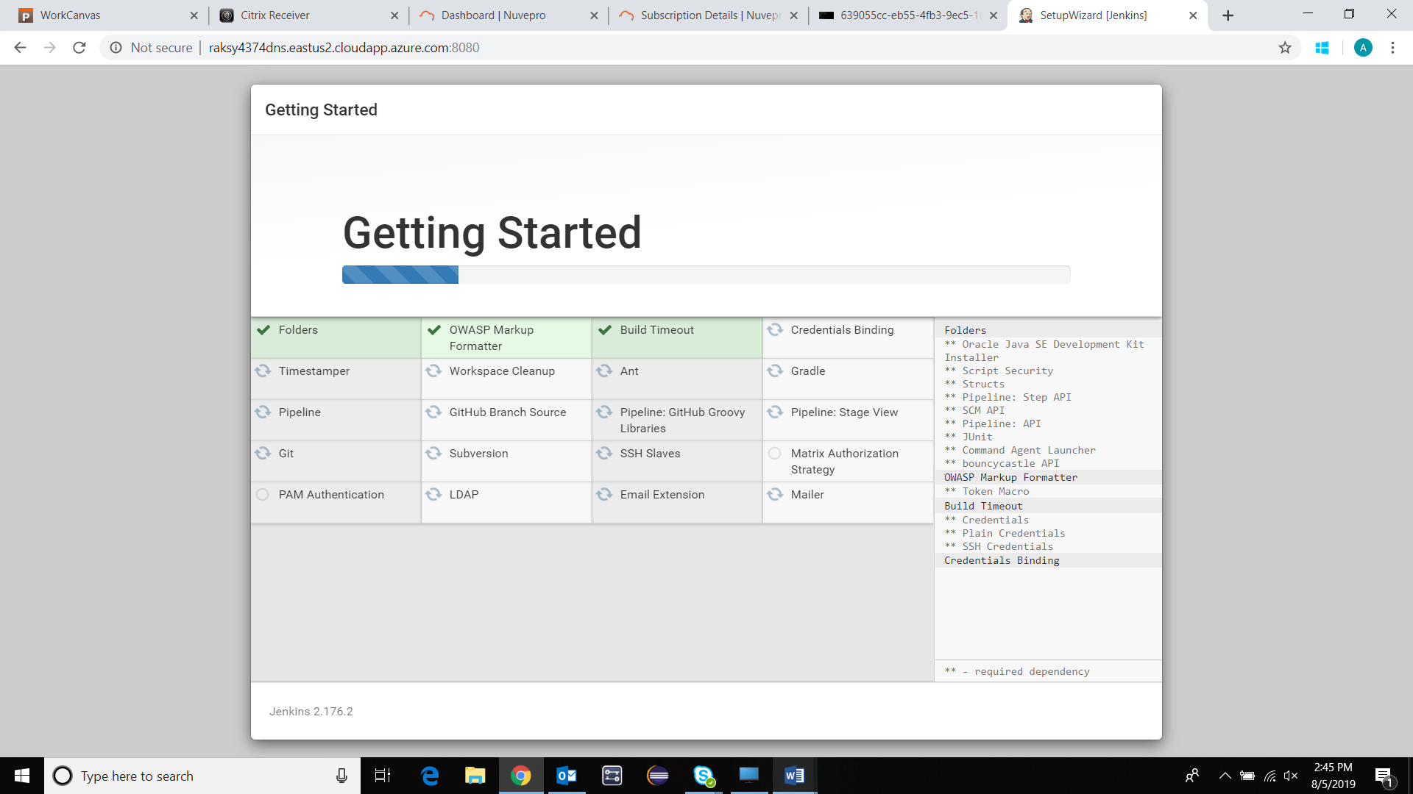

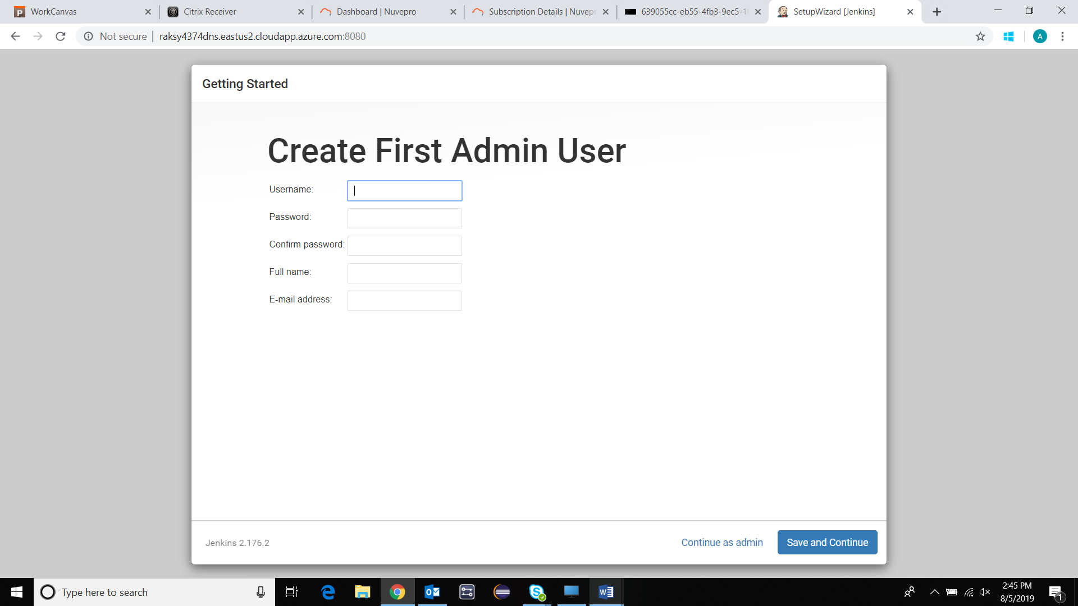

**Enter Details** 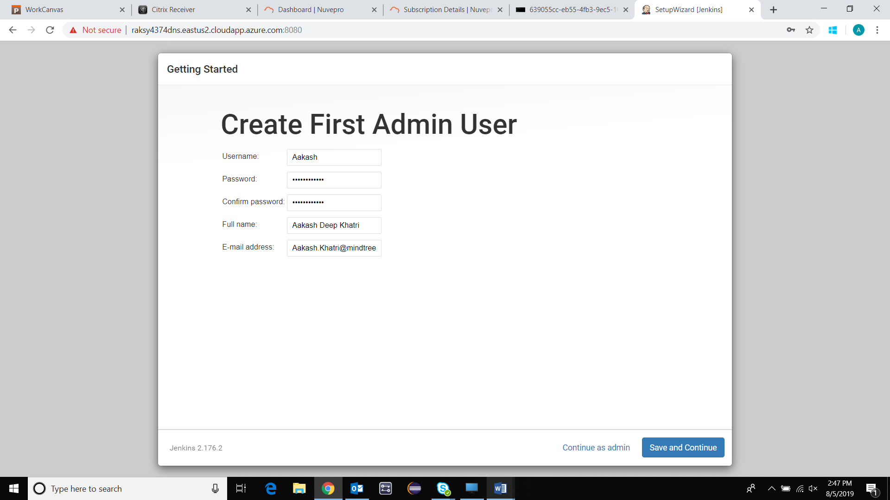

SAVE and CONTINUE 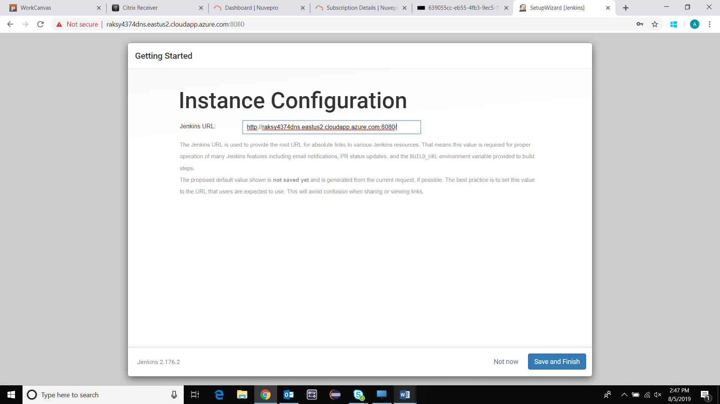

[**http://raksy4374dns.eastus2.cloudapp.azure.com:8080/**](http://raksy4374dns.eastus2.cloudapp.azure.com:8080/)

**SAVE and Finish** 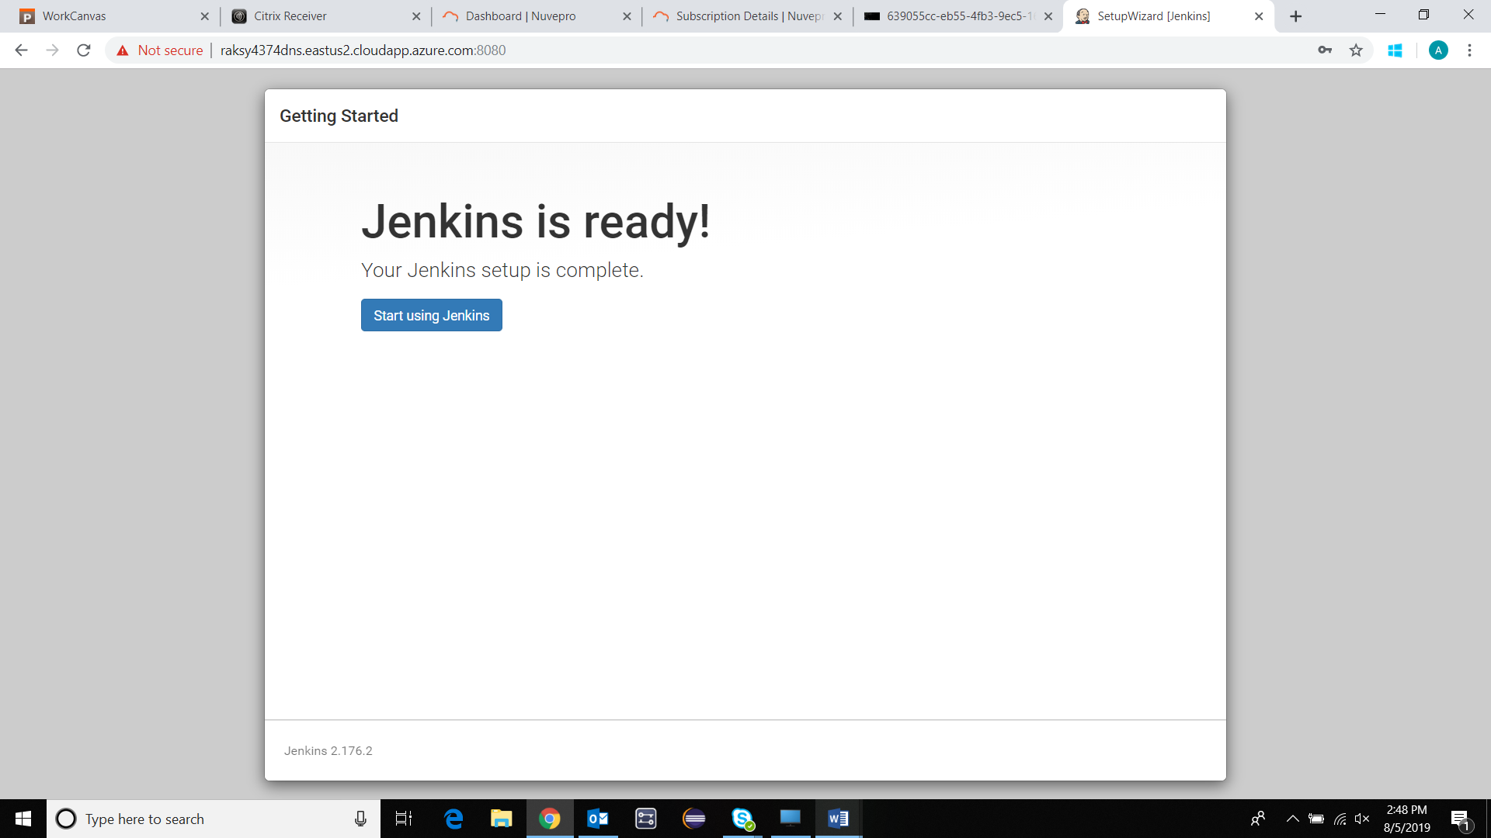

**Start using Jenkins** 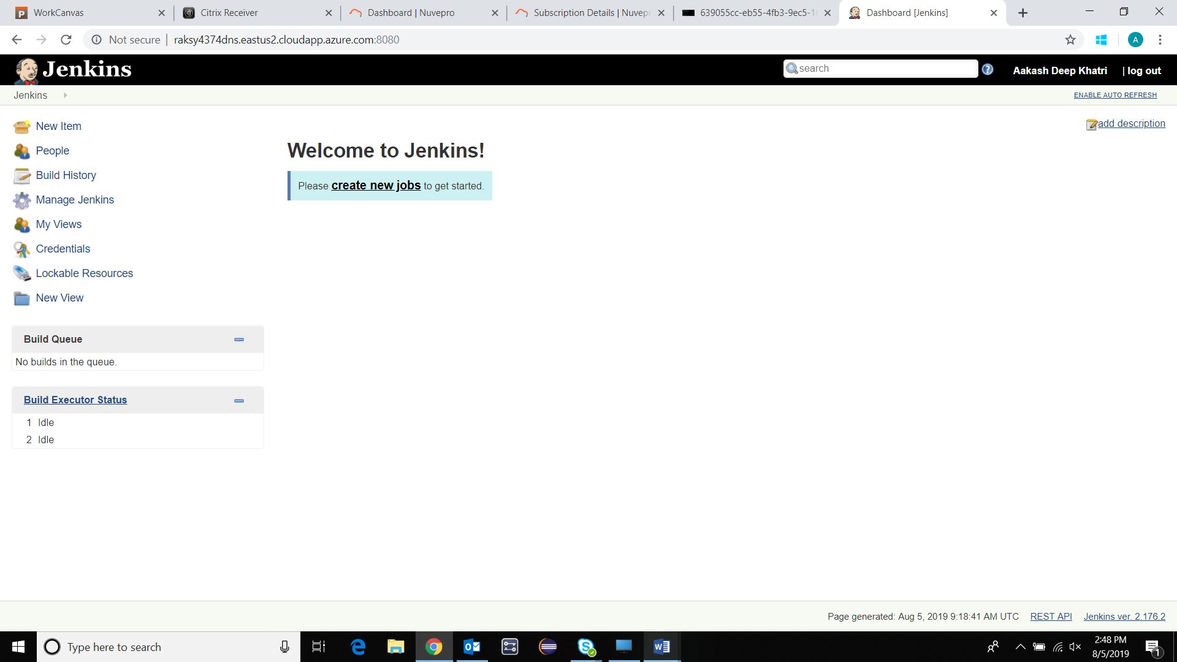

**Adding the WebHooks:** <https://github.com/adkhatri26/Aakash/settings/hooks>

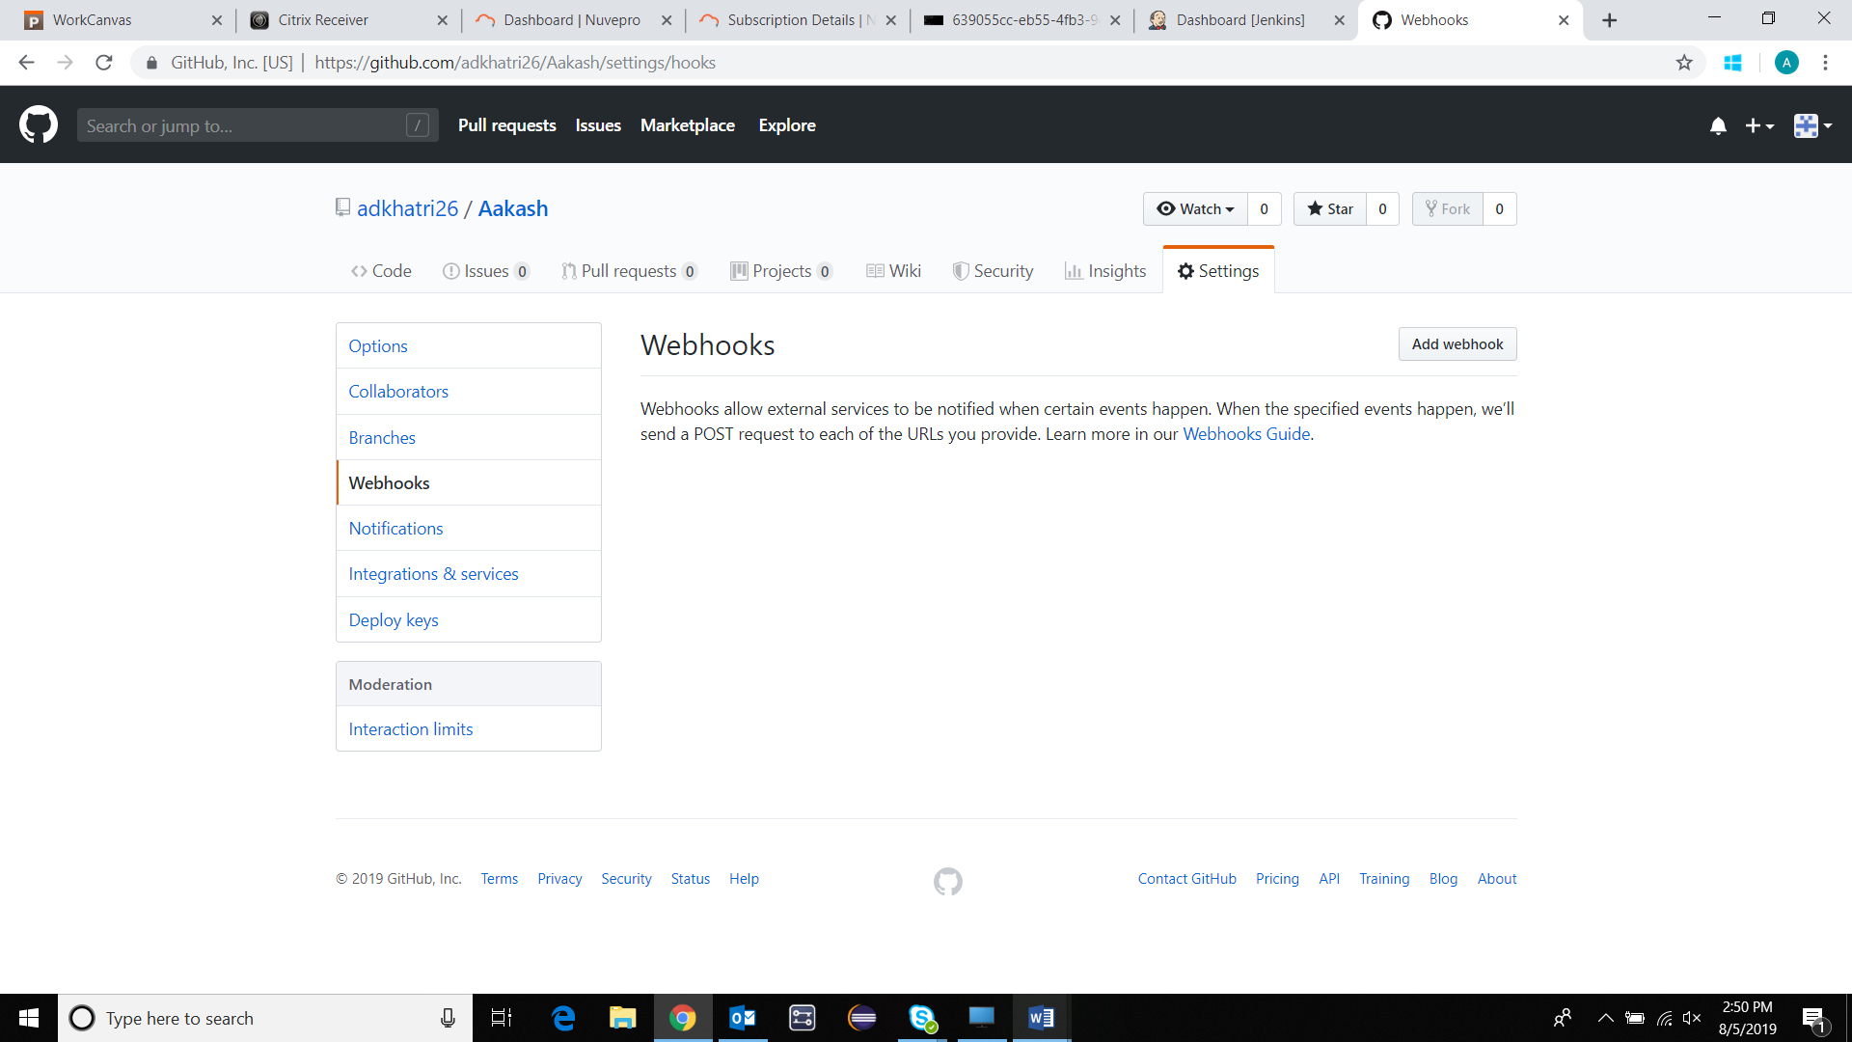

**Add Webhook: Enter Password** 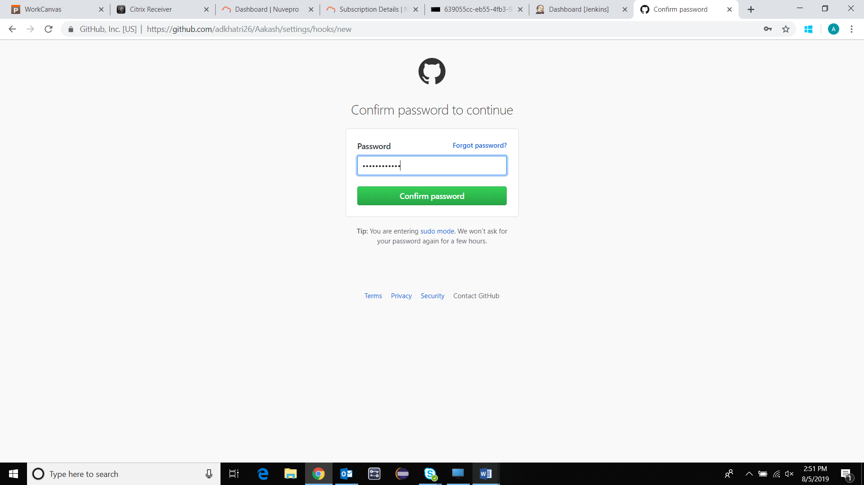

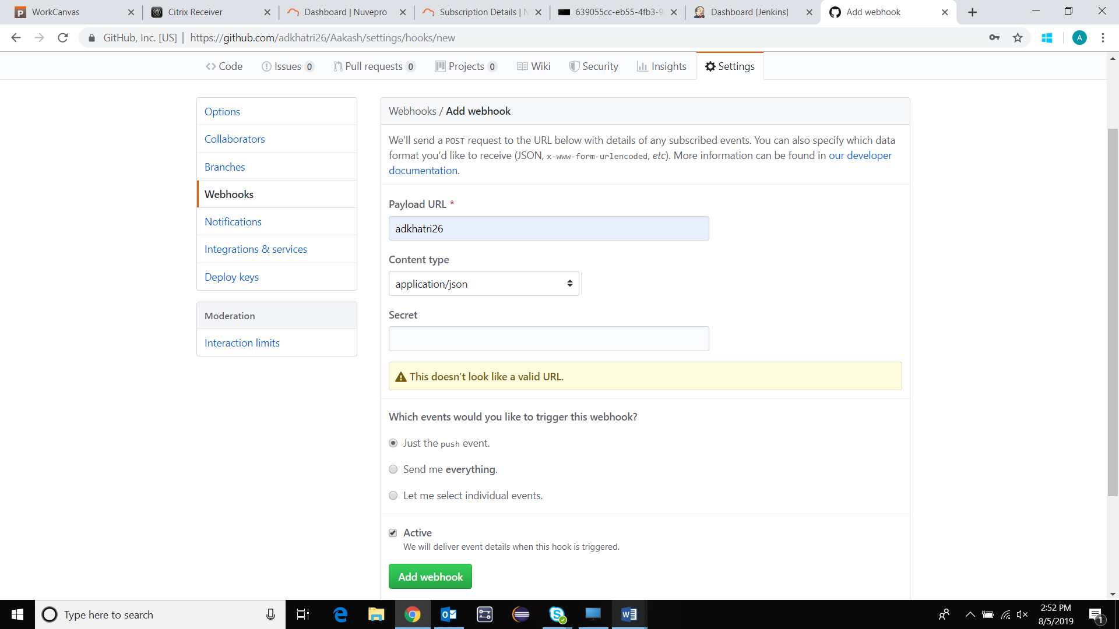

**Add Webhook URL:** [**http://raksy4374dns.eastus2.cloudapp.azure.com/webhook/aakash**](http://raksy4374dns.eastus2.cloudapp.azure.com/webhook/aakash)

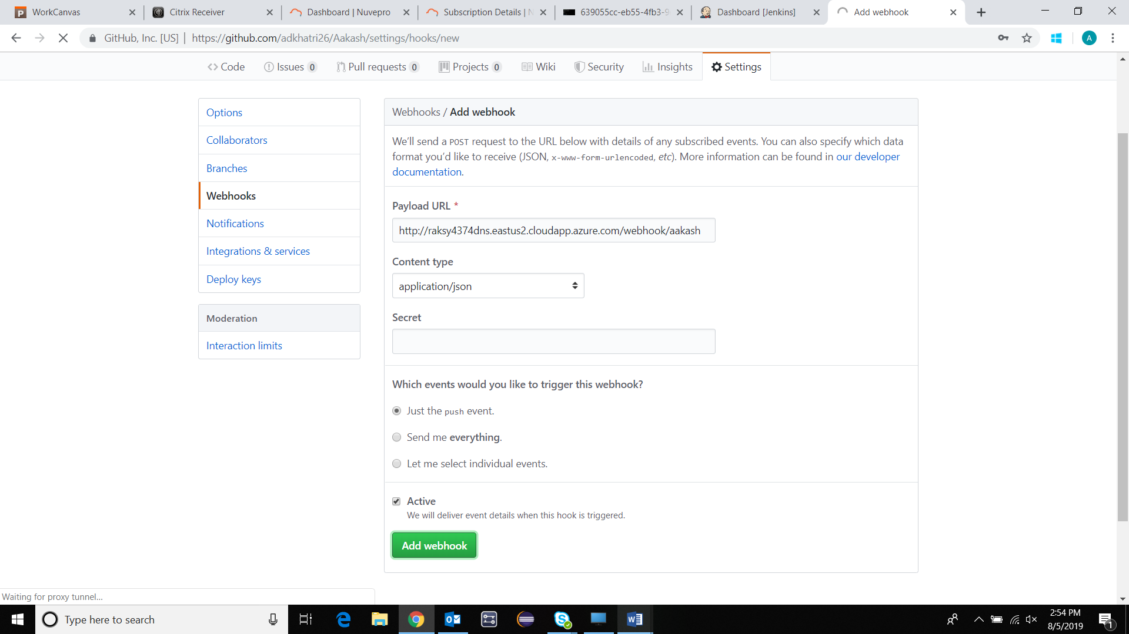

**Add webhook**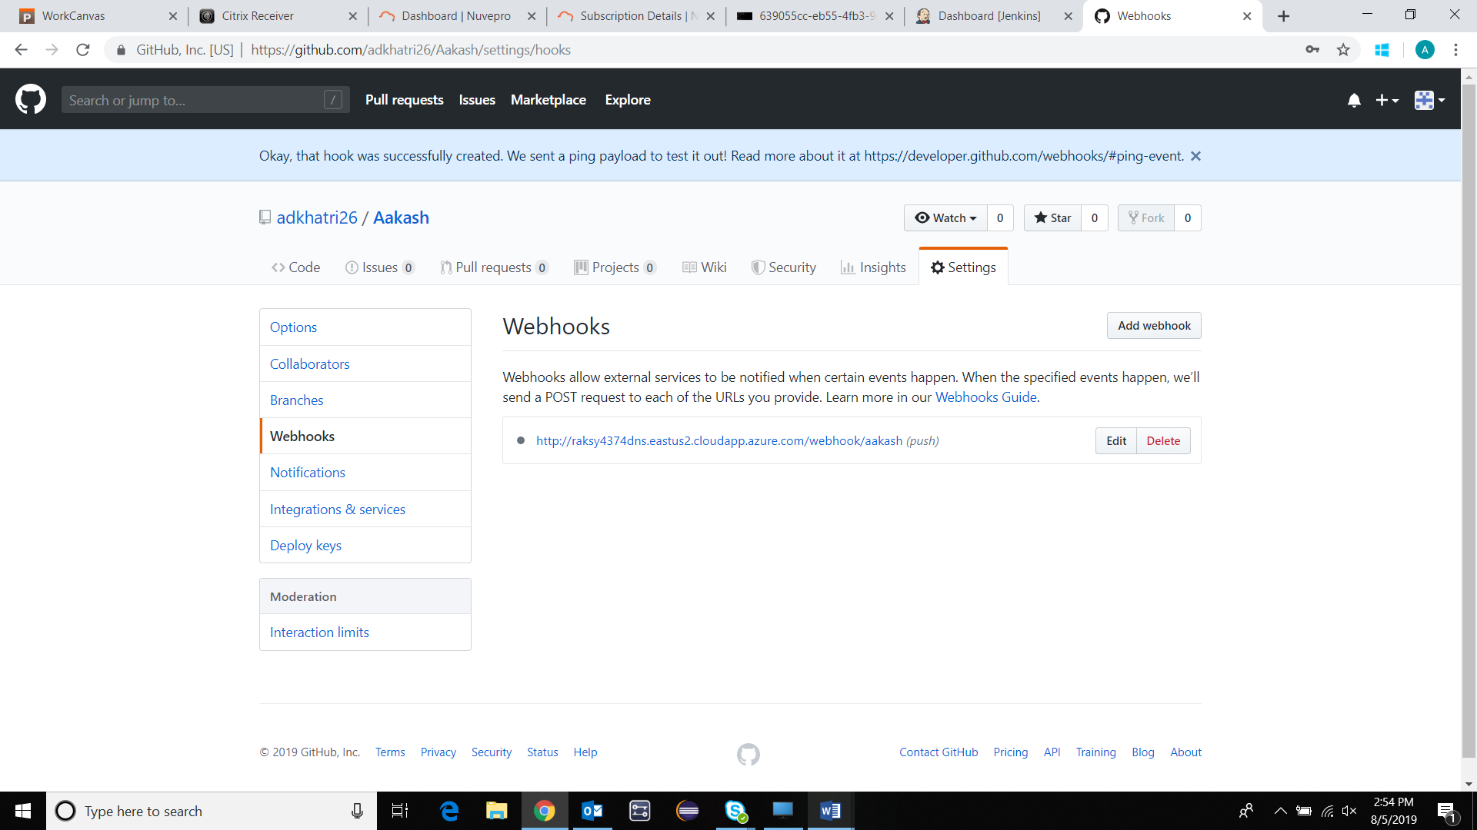

**Integrate GIT – Jenkins**

**Go to Manage Jenkin links 🡪 Check git plugin is installed** 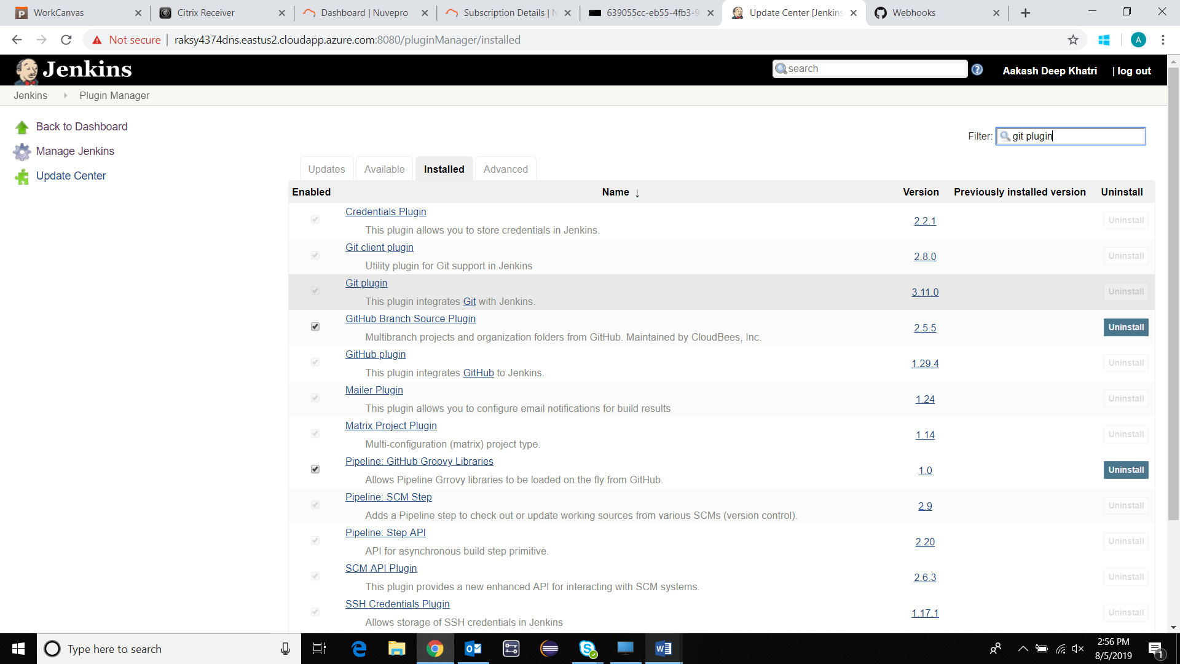

**Create Jenkins job** 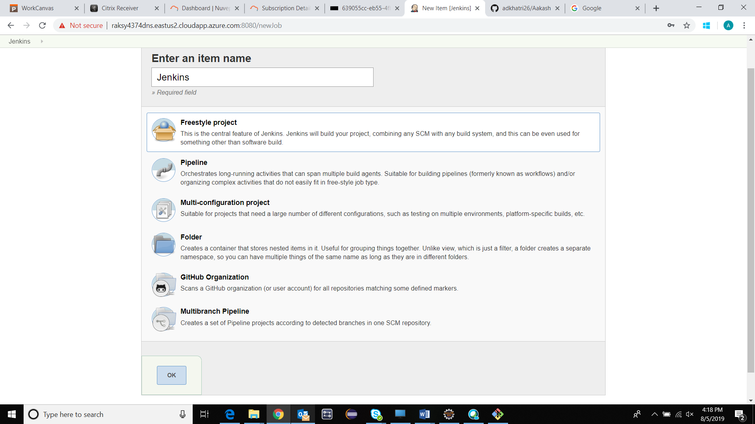

OK 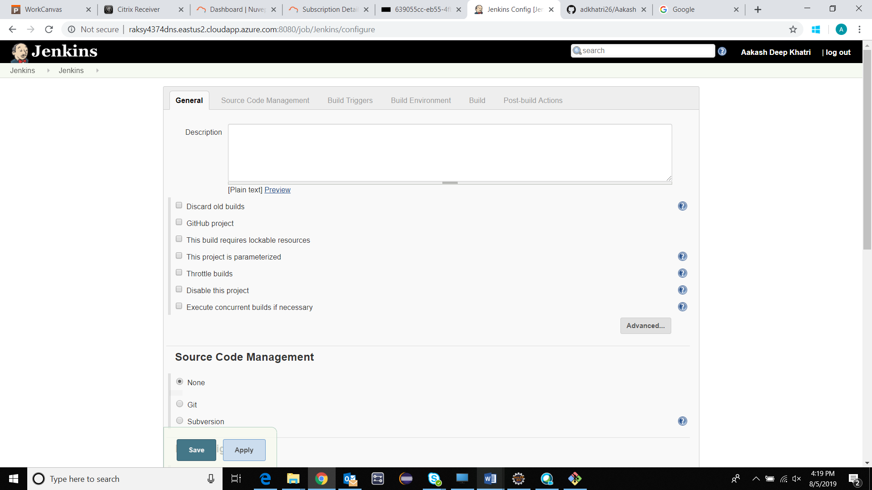

Select: Git 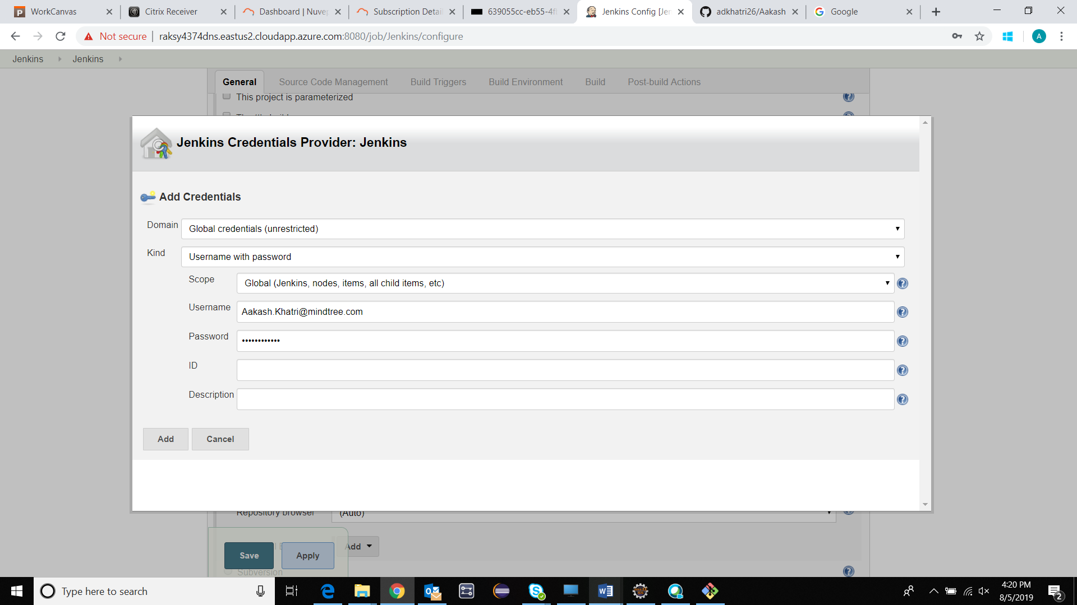

Add 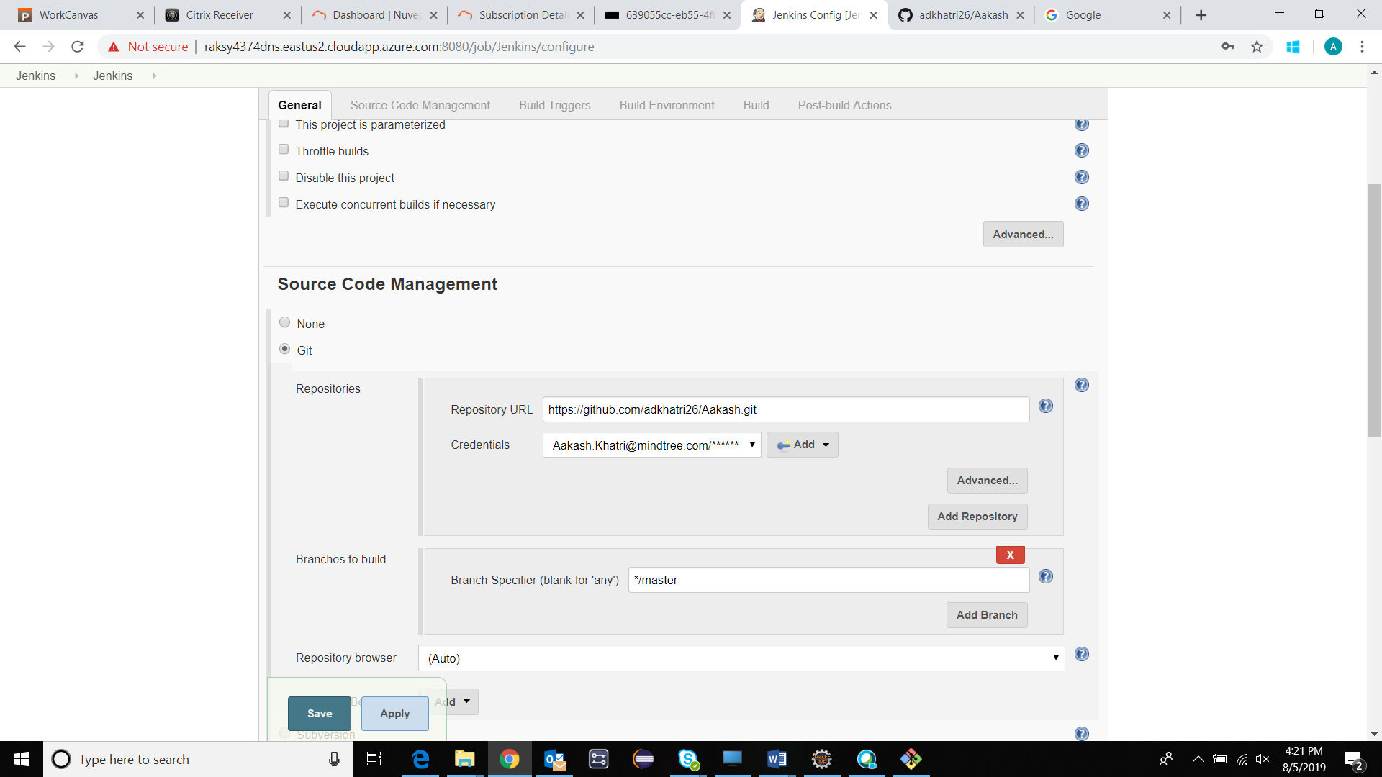

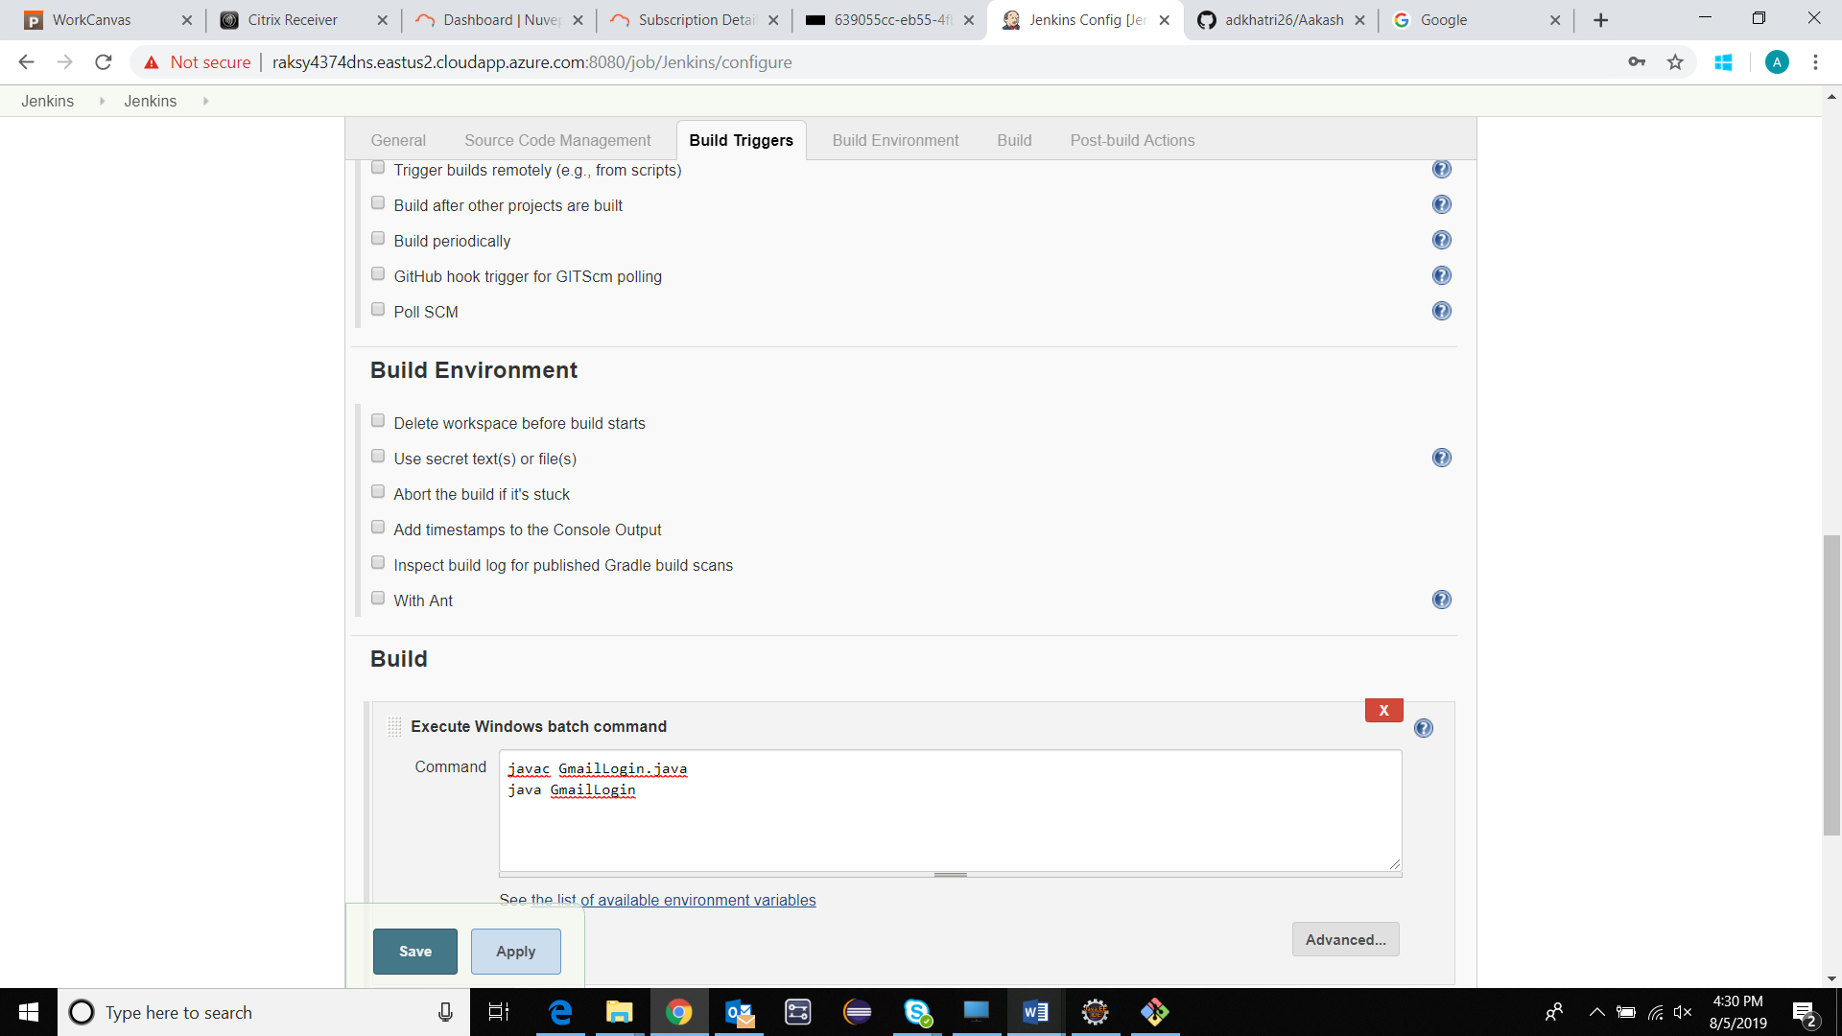

SAVE 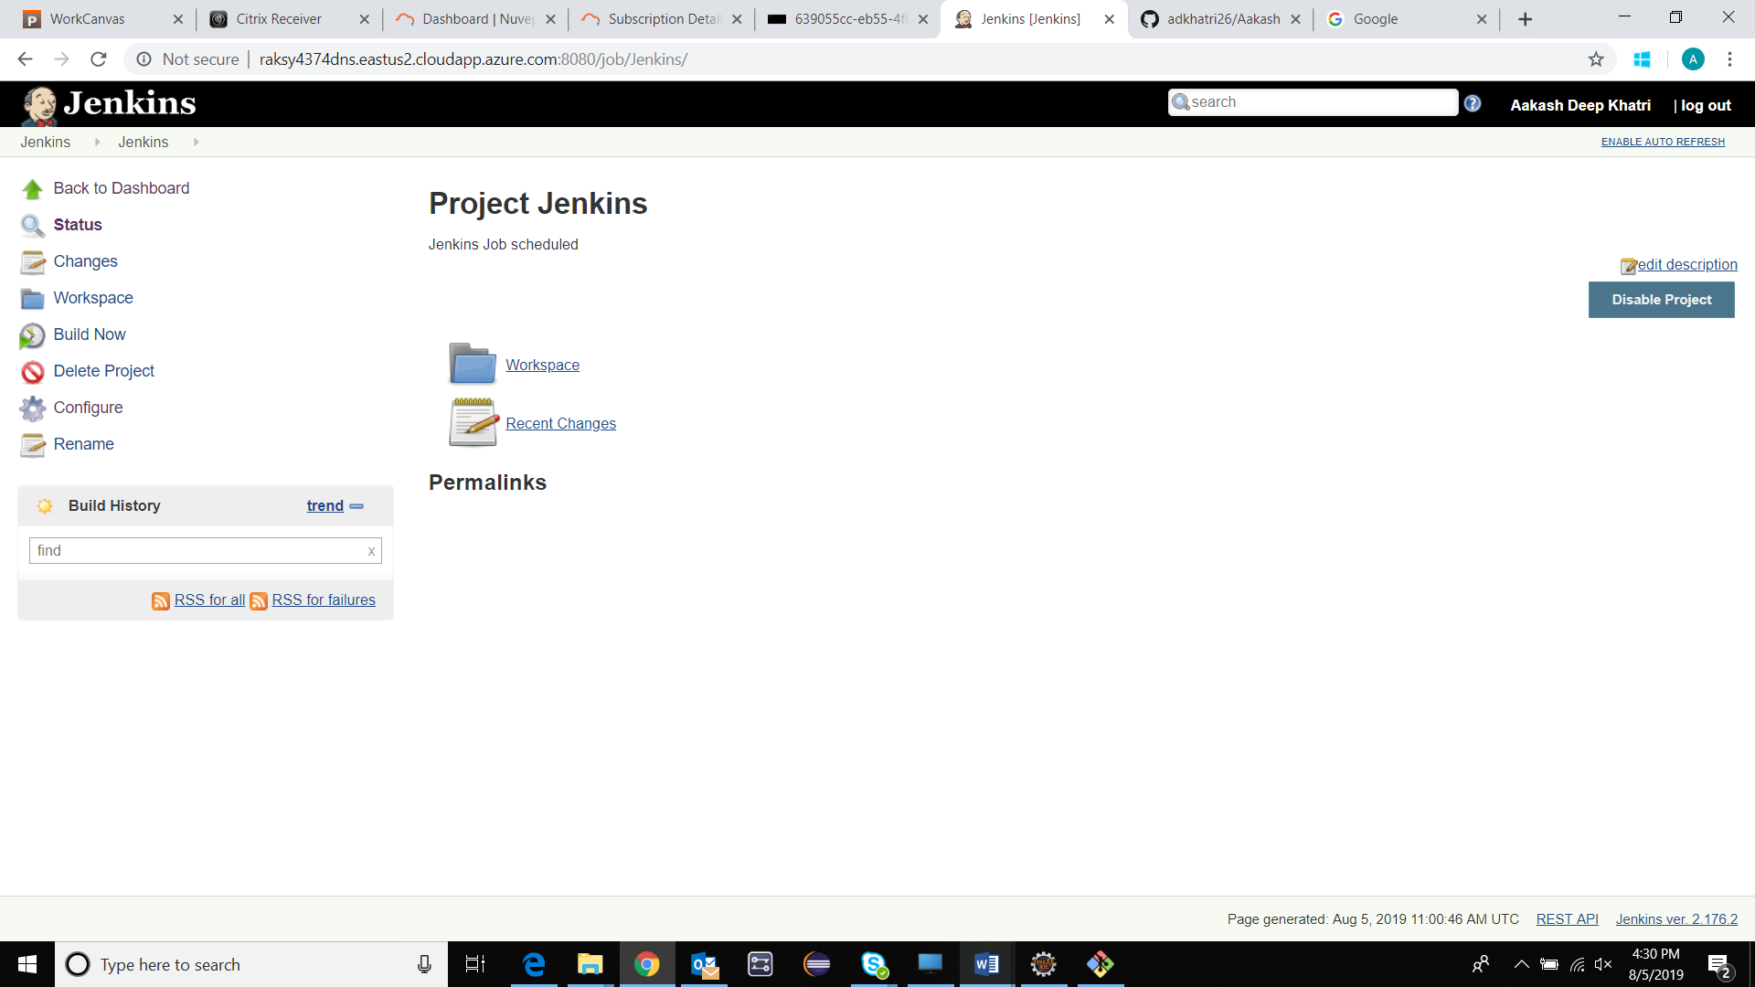

Build Now 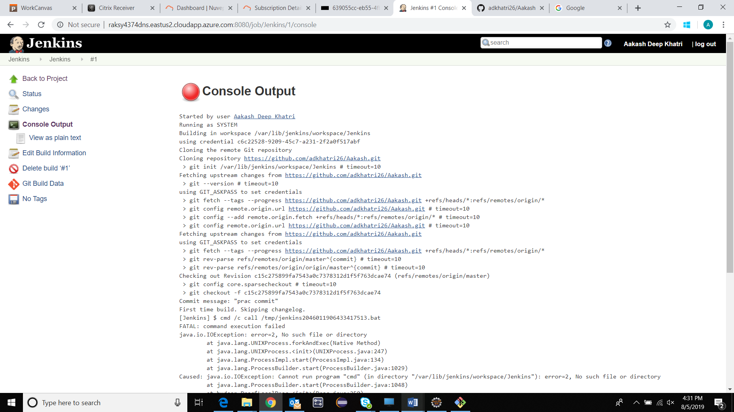

Project: Jenkins2

Hello World 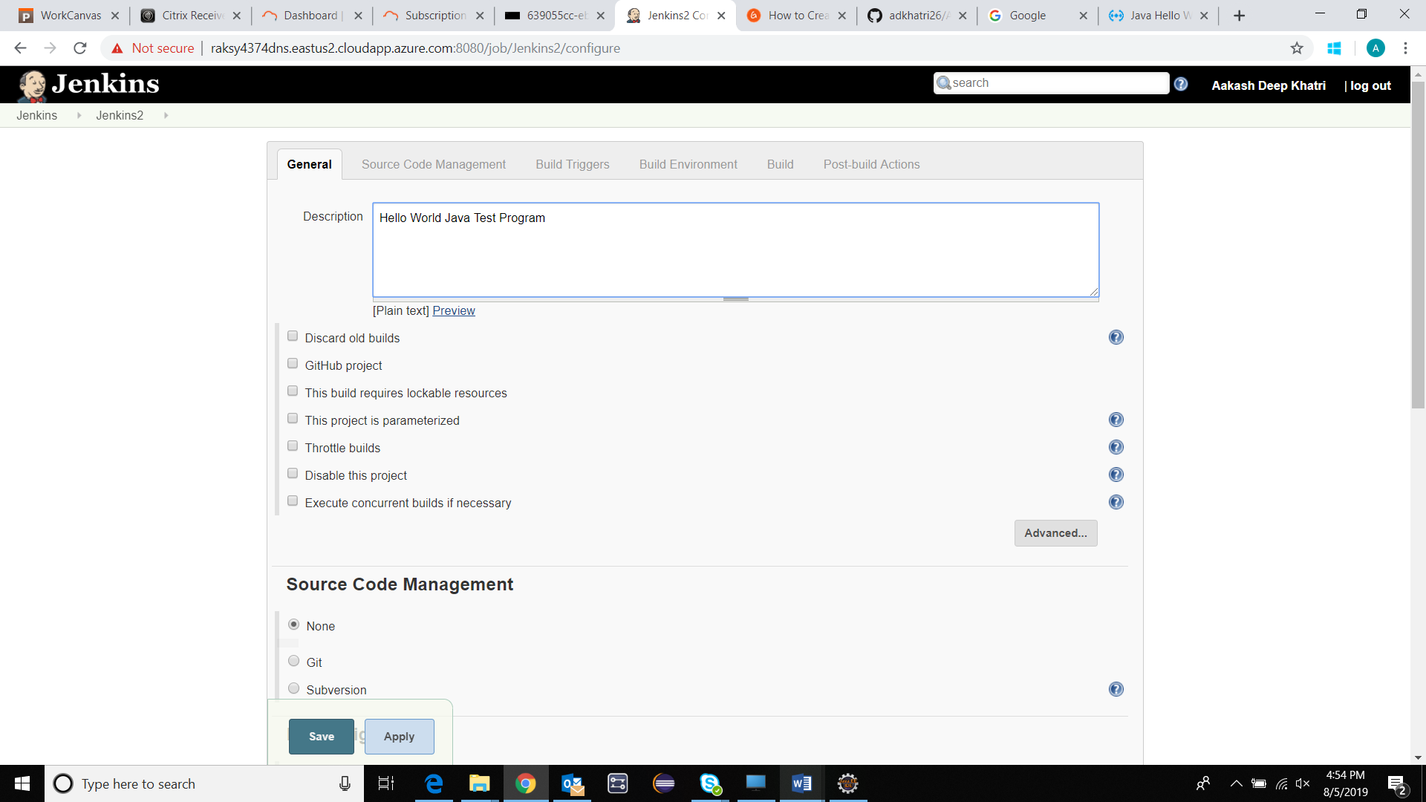

Git 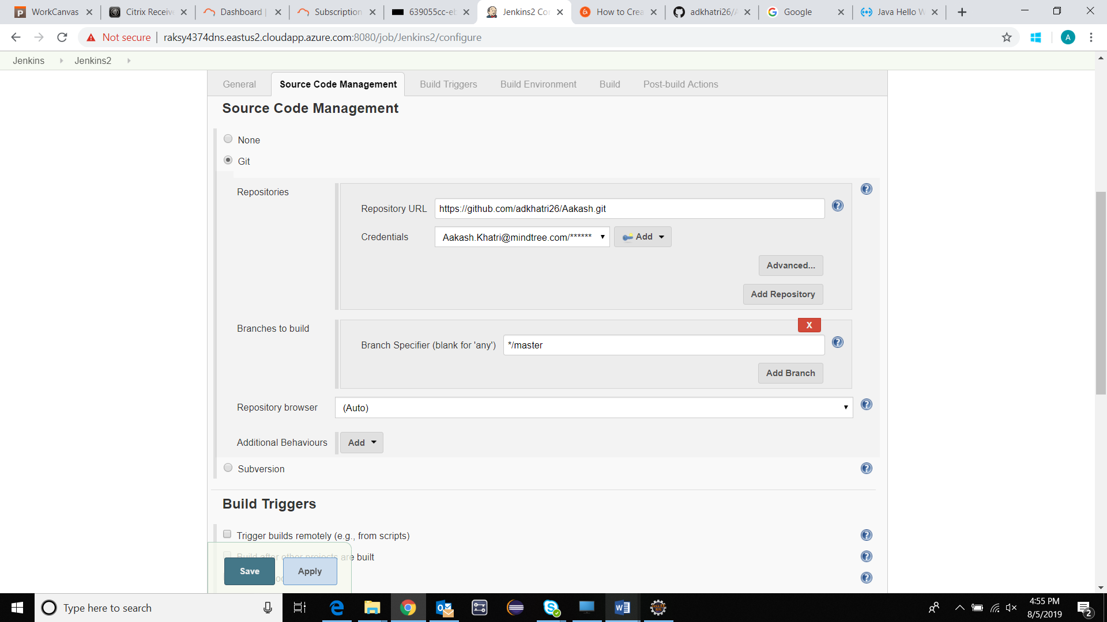

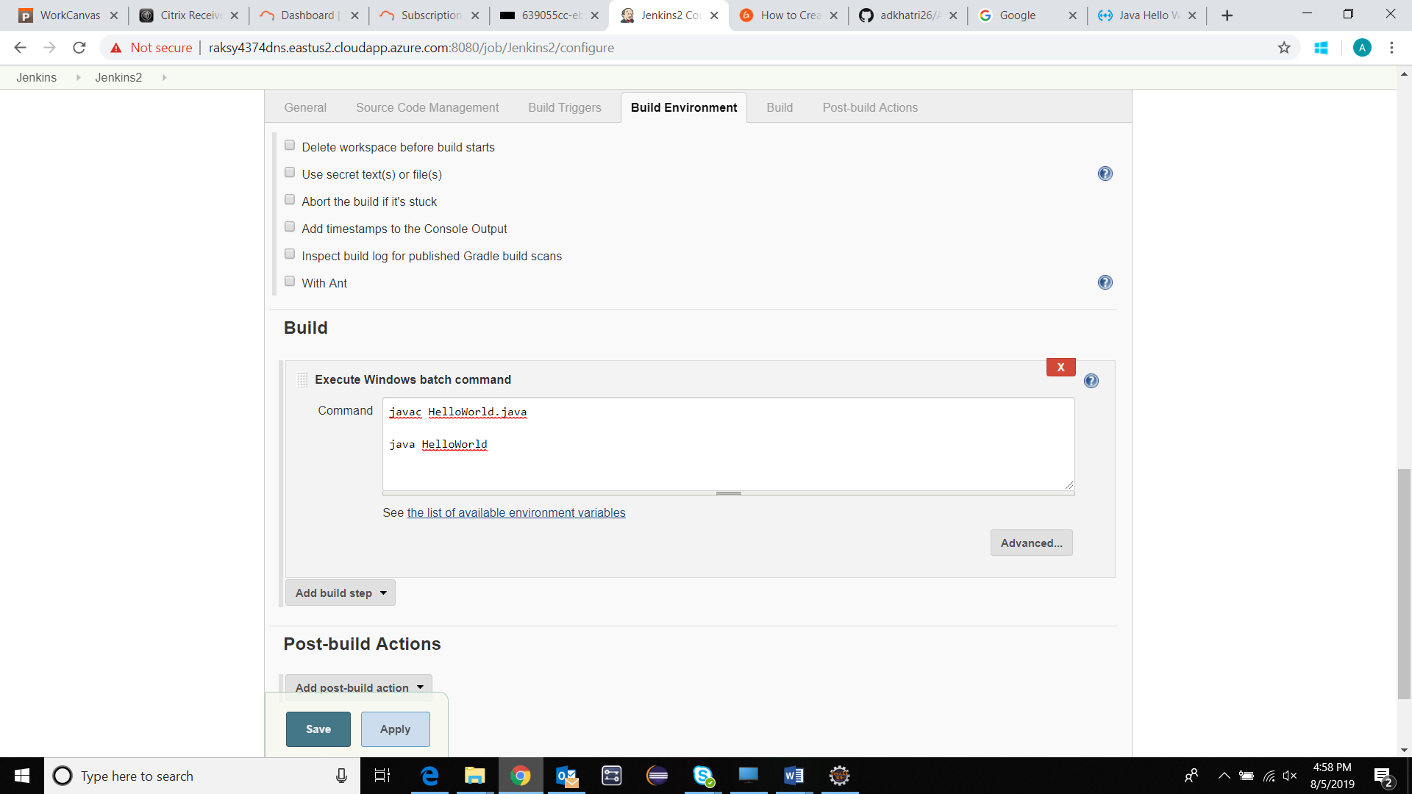

**Apply & Save** 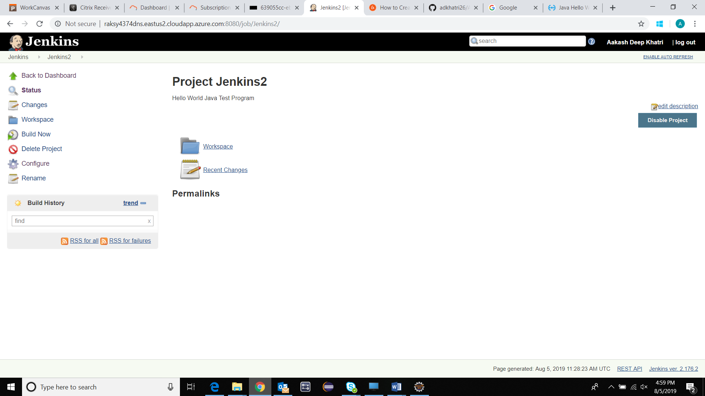

**Build Now** 